Public Community Discovery

Users  - Primary  - Community manager  - Secondary | Phase 1
Intended Outcome
- Organizers create their community profile as they want their communities to become visible to outsiders and prospective members.
Links
- Figma
- …
- …
- …
- …

Introduction
One of the community organizers we invited to try Kolavo ended up leaving after registration and saying that he wanted to see communities in it before creating his own. This seems he did not have the motivation of creating his community profile because he did not know what it would look like. Therefore, we want to motivate community organizers to create their community profiles by making community lists visible to the public.

Product Requirement
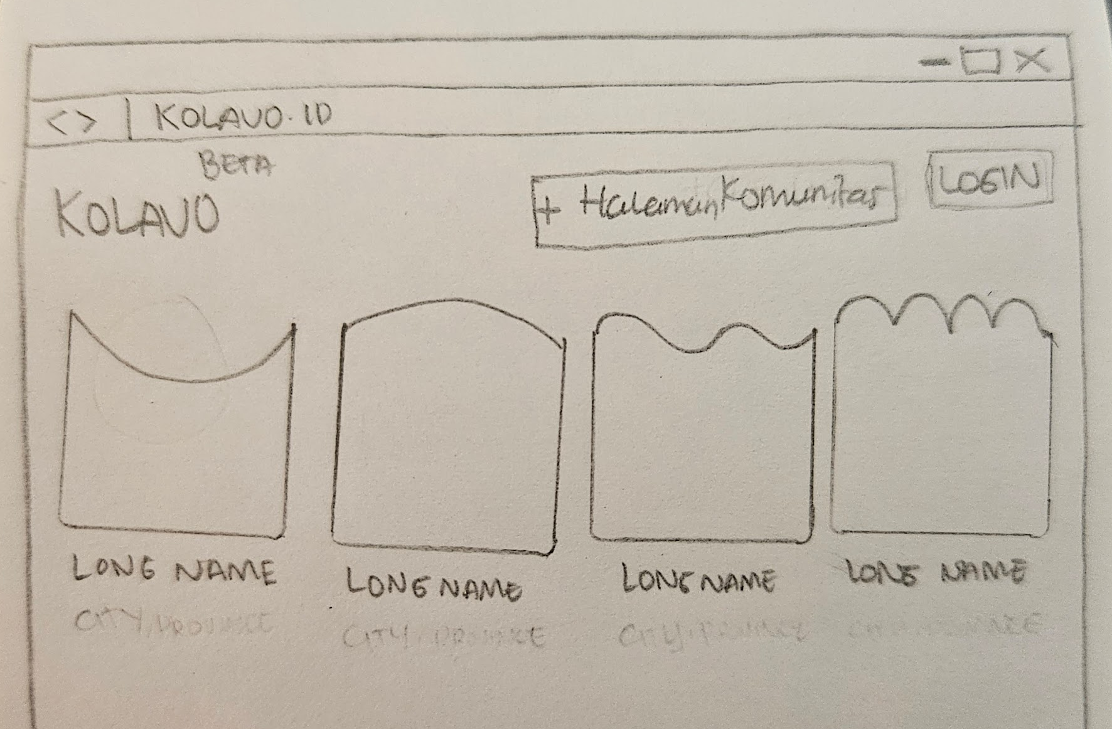
No. | User story | Scope | Acceptance Criteria
1 | As community organizers, I want to see what listed communities look like | Community directory visible to non registered users | - All visitors who access Kolavo.id directed to homepage contains community directory
1 |  | Show fixed first-page display limit in home page | - Each community position should not be fixed. It should be dependent on how much info within each community.
1 |  | Differentiables community identities | Showing:  - Logo  - Long name (5-10 words)
2 | As community organizers, I want to see further information of listed communities | When a community clicked, opens community page | - Community page opened has to be the same with community linked
3 | As community organizers, I want to see community profile listed in community directory | Back button | - Outside community profile area, show back button  - Back button redirect to homepage
4 | As community organizers, I want to create my own community profile | Create community button | - Easy to find  - If not logged in, redirect to login process, then to create community form page  - If logged in, direct to create community form page
5 | As community organizers, I want to access it on mobile phone when needed | Mobile responsive | - Looking tidy when accessing using mobile phone
6 | As community organizers, I want to easily know where to login | Login button | - Easy to find  - When clicked, direct to login page

Design Requirement
No. | Feature | Scope | Acceptance Criteria
1 | Logo Kolavo | Kolavo is still in BETA | Use Kolavo BETA logo
2 | Tambah Halaman Komunitas | - The wording is too long for a button  - It needs to be eye catching and represent Kolavo  - The button should be shorter | - Use + Halaman Komunitas  - Use orange Kolavo  - Use white color of words  - When mouse hover, button color still the same, just add a little bit shadow at the right, left, and down side of the line
3 | Header | - Not too formal  - Use daily conversation | - Copy: Mana Komunitasmu?  - Centre align  - Use H1 format  - Bold and black  - Font size 32px  - Line height 38px  - Letter spacing -1  - Weight 700
4 | Community Logo | - Every community has their own logo shape that it will be good if it has transparent background | - If it is transparent background follow the shape of the logo not the picture uploaded  - Positioned to be at the middle above long name
5 | Long Name | - All looks same but different when mouse hover | - Bold black colour  - When mouse hover, changed to chosen community theme color  - Center align to community logo
6 | Community card | - All looks same but different when mouse hover | - Each community is borderless  - When mouse hover, give very thin transparent Kolavo blue border and a little bit shadow at the right, left, and down side of the line card  - Showing 4 communities in a row  - Showing 40 communities in a page
7 | Login Button | - This needs to be easily visible to but different to Tambah Halaman Komunitas | - The wording is Login  - The color is Kolavo blue  - The text is white  - When mouse hover, button color still the same, just add a little bit shadow at the right, left, and down side of the line card
8 | Mobile Responsive | - Easy and comfortable access | - Black and borderless menu burger accommodate area for both Login and Tambah Halaman Komunitas buttons  - One community card in each row

Engineering Requirement

Questions

